Dahel Consultants & Techies

SALES PERFORMANCE REPORT

FOR

JANUARY 2018

By Bashiru Akintayo

**Sales Performance Report - January 2018**

**Objective:**

To analyze regional sales performance and evaluate individual sales representatives' contributions to recommend incentives, rewards, and promotions.

**Overview:**

In January 2018, the company achieved total revenue of $785,653 from 40 sales across multiple regions. The Eastern region recorded the highest revenue, contributing $211,189, while the Northern region generated the lowest revenue. Performance discrepancies between regions were attributed to several key factors, including security issues, poor logistics, and insufficient advertising in the Northern region compared to other areas.

**Key Findings:**

1. **Regional Performance:**

- Eastern Region: Led all regions with $211,189 in revenue, surpassing $200,000.

- Northern Region: Recorded the lowest sales, primarily due to operational challenges such as security concerns, inadequate logistics, and limited marketing efforts.

2. **Top Sales Representatives by Region:**

- **The top three performers were**:

- Jane – Achieved an average sales value of over $6,000, securing the top position.

- Mark (ID: 1336)

- Janet

- **Bottom Performers**: The lowest performers included:

- Mark (ID: 3305) – The lowest sales performance across all regions.

- James

- David

3. **Lack of Comparative Data:**

- Data for the previous year's sales figures is unavailable, making it difficult to benchmark the January 2018 results against historical performance. This absence of data prevents an accurate assessment of profit growth or decline.

**Issues Identified:**

- **Regional Disparities:** The Northern region's underperformance is largely driven by external factors such as insecurity and poor logistical support, which hindered sales potential.

- **Marketing Deficiencies:** Limited advertising efforts in the Northern region further contributed to reduced sales compared to the more successful regions.

- **Data Gaps**: The absence of comparative data for the same month in the previous year makes it challenging to measure trends, profits, or losses.

**Recommendations:**

1. **Set Revenue Targets**: Establish clear sales and revenue benchmarks to track future performance and growth.

2. **Address Regional Gaps:**

- Focus on improving logistical support and security measures in the Northern region to unlock potential sales growth.

- Allocate more advertising resources to the Northern region to address market awareness gaps.

3**. Leverage Successful Strategies**:

- Analyze the techniques and strategies employed by the top-performing salespeople, particularly Jane, to identify best practices.

- Implement these successful approaches across all regions, especially those underperforming, to drive improved sales results.

The next page provides a detailed sales dashboard for January 2018.

SALES DASHBOARD



YEAR - 2018

**NUMBER OF SALES**

**40**



**SALES PERSON**

**10**



**REGIONS**

**4**



**TOTAL SALES**

**$ 785,653**

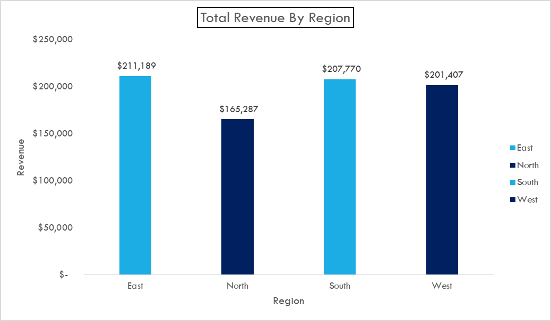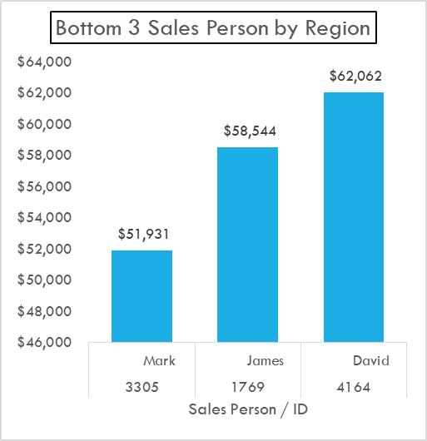

**Conclusion:**

The sales analysis for January 2018 highlights significant regional disparities, with the Eastern region leading in revenue while the Northern region lags due to challenges such as insecurity, poor logistics, and limited advertising. The top-performing sales representatives, particularly Jane, demonstrated strong sales capabilities, which should be leveraged as models for improving overall performance. However, the lack of comparative data from previous periods limits the ability to assess growth trends or evaluate profit margins accurately.

To drive future sales success, it is essential to set clear revenue targets, address operational inefficiencies in underperforming regions, and adopt the strategies of top-performing salespeople across all areas. By focusing on these key areas, the business can enhance its overall sales performance and better incentivize its sales team.